**Annual Summary Statistics**

Fees Dataframe:

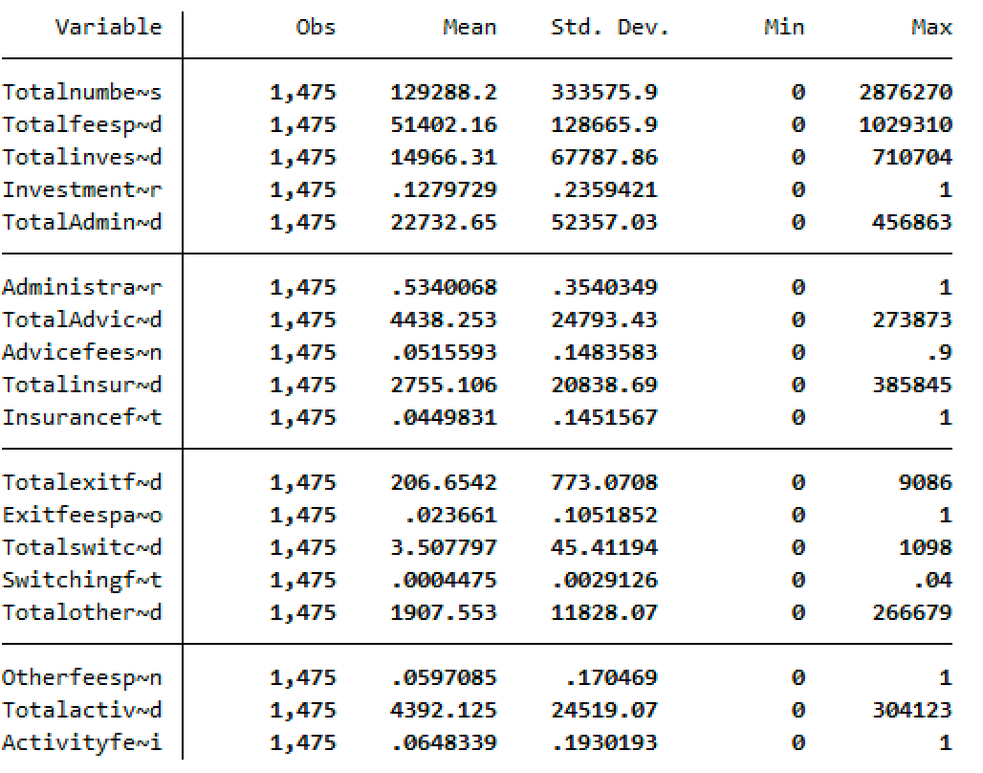

Fees Merged Dataframe:

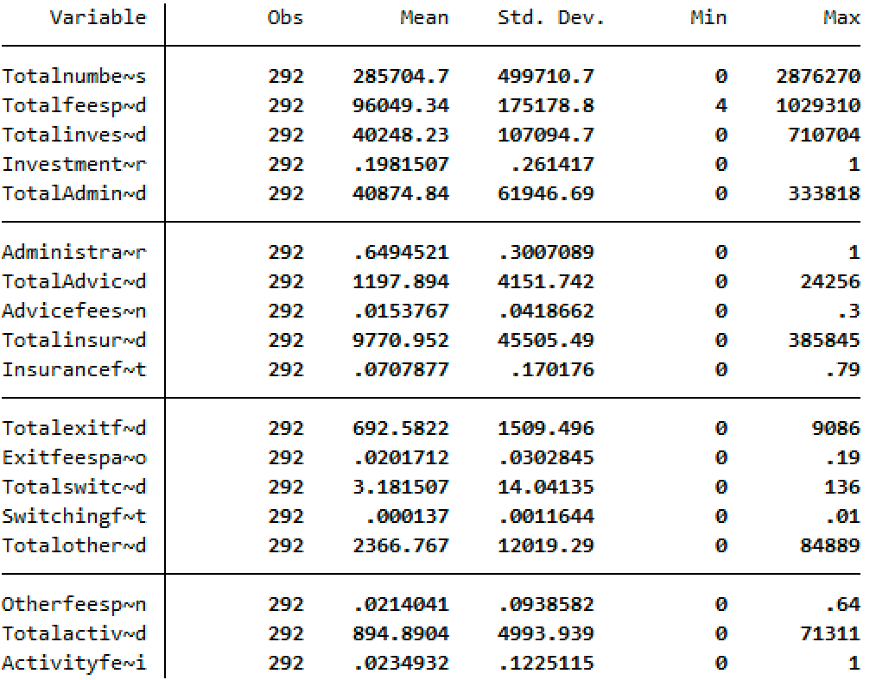

Fees Non-Merged Dataframe:

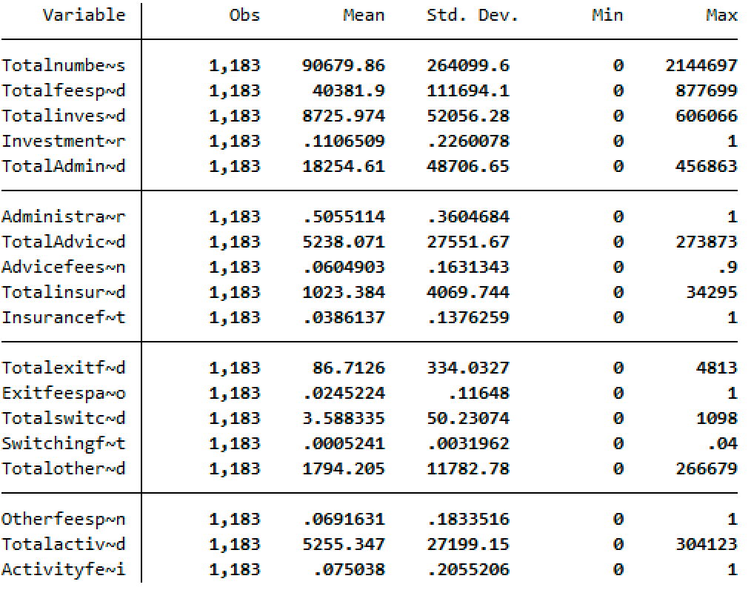

Financial Performance Dataframe:

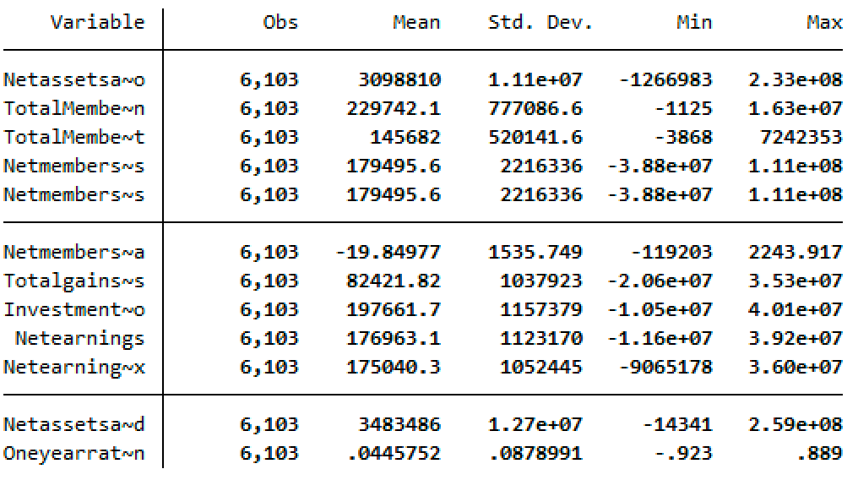

Financial Performance Dataframe:

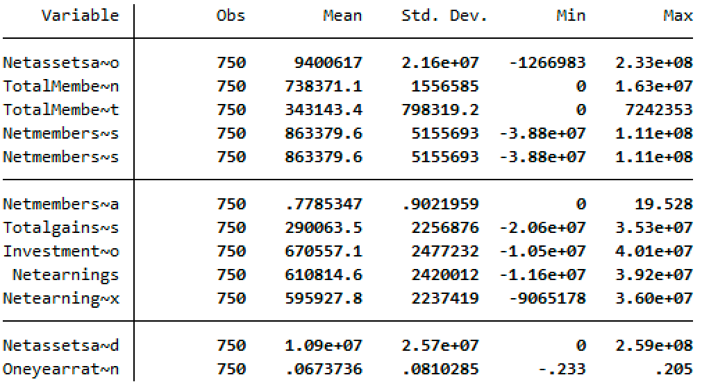

Financial Performance Non-merged Dataframe:

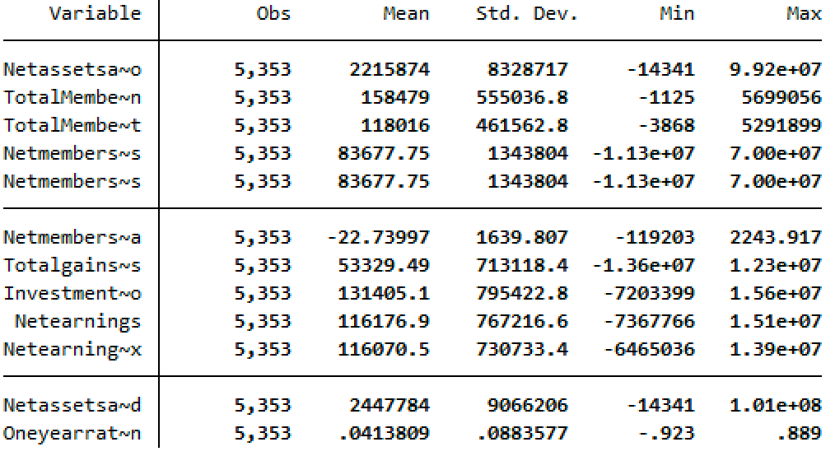

Fund Profile Dataframe:

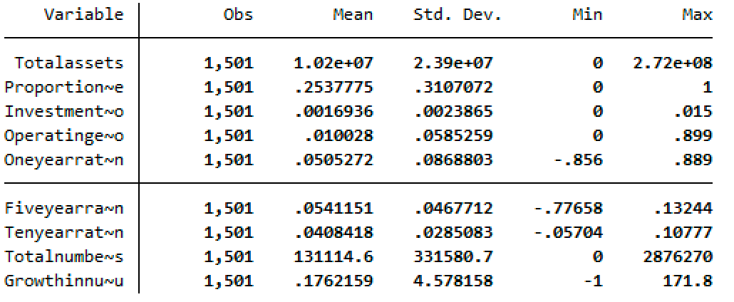

Fund Profile Merged Dataframe:

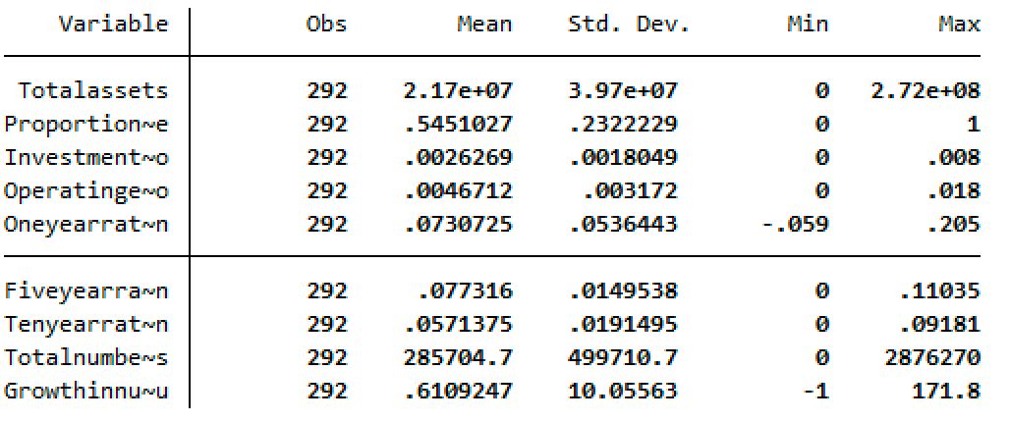

Fund Profile non-merged Dataframe:

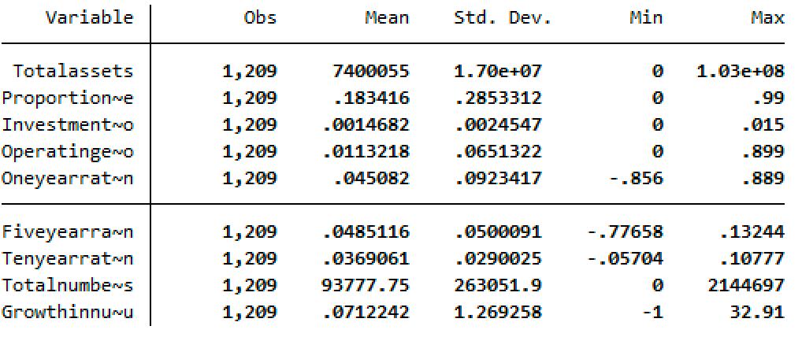

**Quarterly Dataframe**

Fund Profile Dataframe:

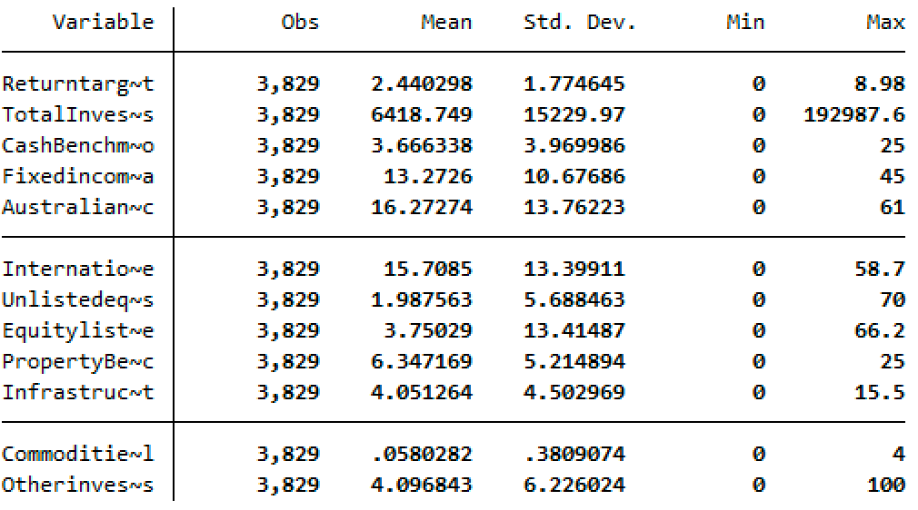

Fund Profile Merged Dataframe:

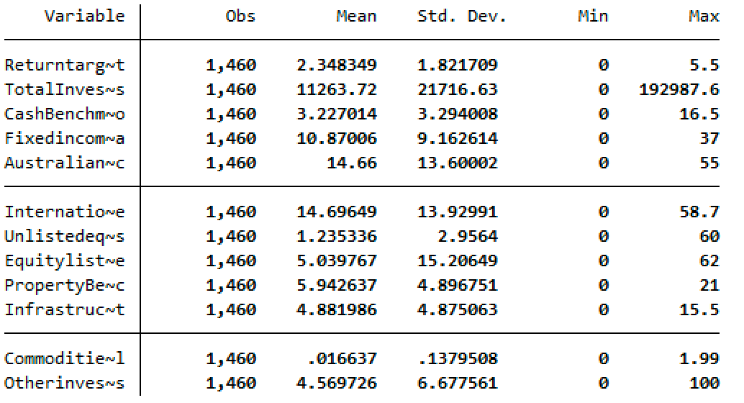

Fund Profile Non-Merged Dataframe:

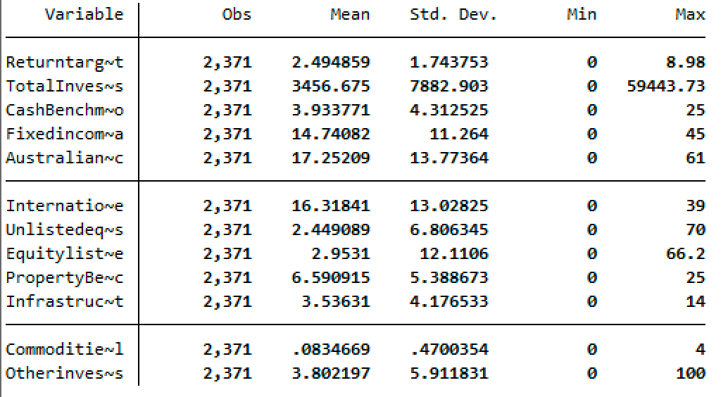

Investment Performance Dataframe:

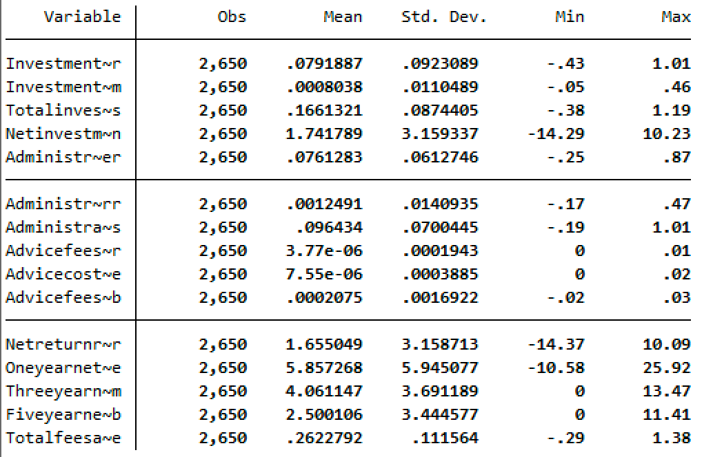

Investment Performance Merged Dataframe:

Investment Performance Non-Merged Dataframe:

MySuper fees dataframe:

MySuper Fees Merged dataframe:

MySuper Fees Non-Merged dataframe:

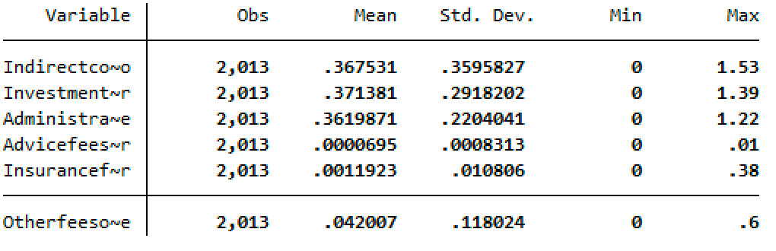

Administration Fee Dataframe:

Administration fee merged dataframe:

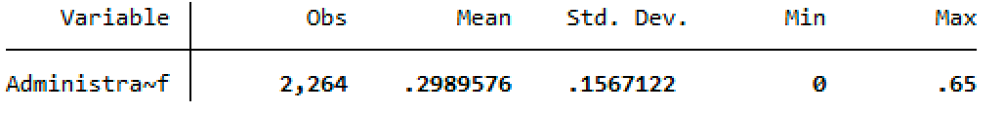

Administration fee non-merged dataframe:

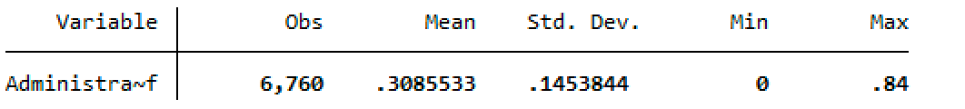

Activity fee dataframe:

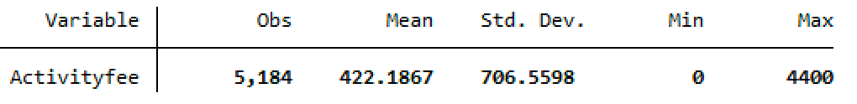

Activity fee merged dataframe:

Activity fee non-merged dataframe:

